Praktikum Algoritma & Struktur Data

**Prak 3.1. Single Linked List: SLL – Delete**

**Dosen Pengampu**

Dr. Tita Karlita S.Kom, M.Kom



**Disusun Oleh :**

Nama : M. Faza Nur Husain

Nrp : 3121550004

**D3 PJJ AK TEKNIK INFORMATIKA**

**POLITEKNIK ELEKTRONIKA NEGERI SURABAYA**

**TAHUN AKADEMIK 2021/2022**

Mengerjakan soal:

1. Delete Awal
2. Delete Akhir
3. Delete Node Tertentu
4. Menu Insert Delete
5. Delete Awal

Source Code :

|  |
| --- |
| #include <stdio.h>  #include <stdlib.h>  typedef struct simpul Node;  struct simpul{  int data;  Node *next;  };  Node *head=NULL, *p;  void alokasi();  void awal();  void tampil();  void hapus_awal();  void bebaskan(Node *);  int main()  {  char jwb;  puts("Single Link List - Delete Awal");  do {  fflush(stdin);  alokasi();  akhir();  fflush(stdin);  printf("lagi (y/t) ? ");  jwb = getchar();  }while((jwb == 'y')||(jwb == 'Y'));  puts("");  tampil();  puts("menghapus node pertama..");  hapus_awal();  tampil();  return 0;  }  void bebaskan(Node *x){  free(x);  x = NULL;  }  void hapus_awal(){  Node *hapus;  hapus = head;  if (hapus -> next == NULL)  head = NULL;  else{  head = hapus->next;  bebaskan(hapus);  }  }  void akhir(){  Node *tail;  if(head == NULL)  head = p;  else{  tail = head;  while(tail->next != NULL)  tail=tail->next;  tail->next = p;  tail=tail->next;  }  }  void tampil(){  Node *baca;  puts("isi dari SLL");  baca = head;  while(baca !=NULL){  printf("%d\n", baca->data);  baca = baca->next;  }  }  void alokasi(){  int x;  printf("Data yang mau disimpan : ");  scanf("%d", &x);  p = (Node *) malloc(sizeof(Node));  if(p==NULL){  puts("alokasi gagal");  exit(0);  }else{  p->data = x;  p->next = NULL;  }  }  void awal(){  if(head != NULL)  p->next = head;  head = p;  } |

Output :

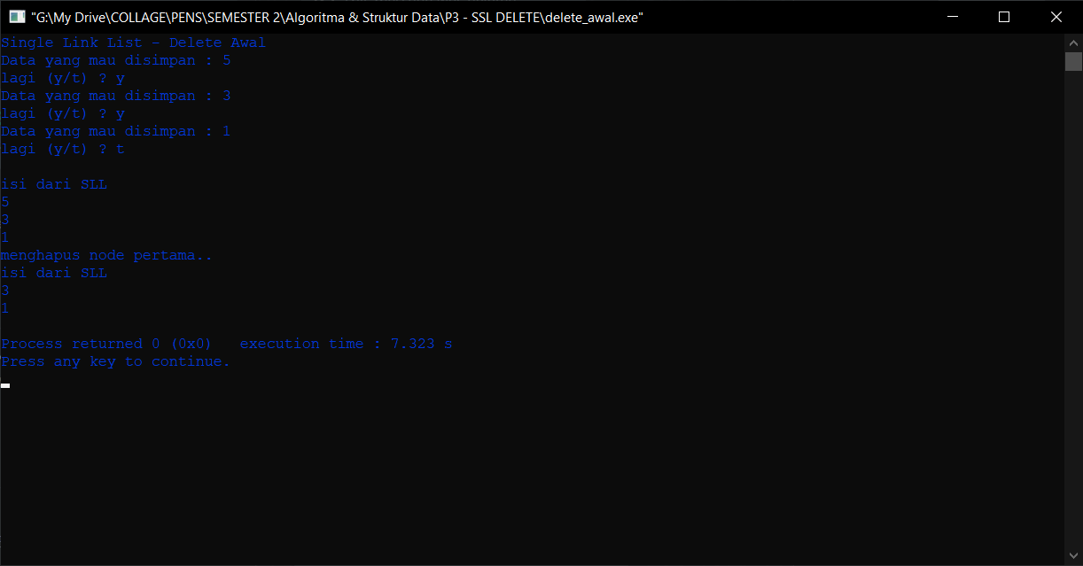

1. Delete Akhir

Source Code :

|  |
| --- |
| #include <stdio.h>  #include <stdlib.h>  typedef struct simpul Node;  struct simpul{  int data;  Node *next;  };  Node *head=NULL, *p;  void alokasi();  void awal();  void tampil();  void bebaskan(Node *);  void hapus_akhir();  int main()  {  char jwb;  puts("Single Link List - Delete Akhir");  do {  fflush(stdin);  alokasi();  akhir();  fflush(stdin);  printf("lagi (y/t) ? ");  jwb = getchar();  }while((jwb == 'y')||(jwb == 'Y'));  puts("");  tampil();  puts("menghapus node terakhir..");  hapus_akhir();  tampil();  return 0;  }  void bebaskan(Node *x){  free(x);  x = NULL;  }  void hapus_akhir(){  Node *hapus, *phapus;  hapus = head;  if(hapus->next==NULL)  head = NULL;  else{  while (hapus->next != NULL)  {  phapus = hapus;  hapus = hapus -> next;  }  phapus -> next = NULL;  }  bebaskan(hapus);  }  void akhir(){  Node *tail;  if(head == NULL)  head = p;  else{  tail = head;  while(tail->next != NULL)  tail=tail->next;  tail->next = p;  tail=tail->next;  }  }  void tampil(){  Node *baca;  puts("isi dari SLL");  baca = head;  while(baca !=NULL){  printf("%d\n", baca->data);  baca = baca->next;  }  }  void alokasi(){  int x;  printf("Data yang mau disimpan : ");  scanf("%d", &x);  p = (Node *) malloc(sizeof(Node));  if(p==NULL){  puts("alokasi gagal");  exit(0);  }else{  p->data = x;  p->next = NULL;  }  }  void awal(){  if(head != NULL)  p->next = head;  head = p;  } |

Output :

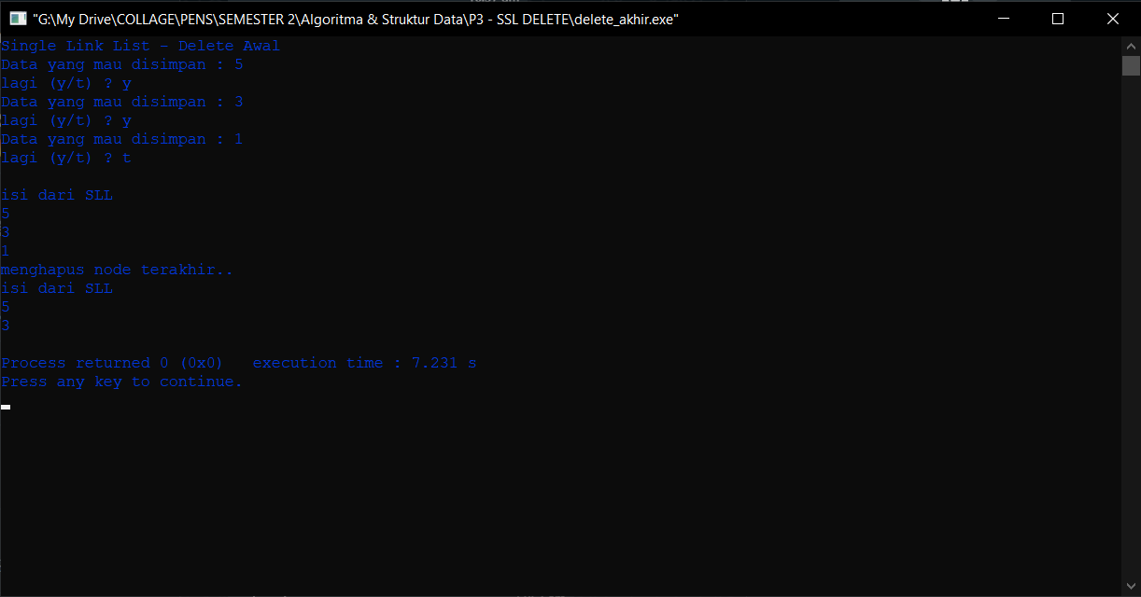

1. Delete Node Tertentu

Souce Code :

|  |
| --- |
| #include <stdio.h>  #include <stdlib.h>  typedef struct simpul Node;  struct simpul{  int data;  Node *next;  };  Node *head=NULL, *p;  void alokasi();  void awal();  void tampil();  void bebaskan(Node *);  void hapus_awal();  void hapus_node_tertentu();  int main()  {  char jwb;  puts("Single Link List - Delete Node Tertentu");  do {  fflush(stdin);  alokasi();  akhir();  fflush(stdin);  printf("lagi (y/t) ? ");  jwb = getchar();  }while((jwb == 'y')||(jwb == 'Y'));  puts("");  tampil();  puts("menghapus node tertentu..");  fflush(stdin);  hapus_node_tertentu();  tampil();  return 0;  }  void bebaskan(Node *x){  free(x);  x = NULL;  }  void hapus_node_tertentu(){  Node *hapus, *phapus;  int key;  printf("data yang mau dihapus ?");  scanf("%d", &key);  hapus = head;  hapus = head;  if(hapus->data==key)  hapus_awal();  else{  while (hapus->data != key)  {  if (hapus->next==NULL)  {  printf("%d tidak ada dalam SLL\n", key);  exit(0);  }else{  phapus = hapus;  hapus = hapus->next;  }    }  phapus->next = hapus->next;  bebaskan(hapus);  }  }  void hapus_awal(){  Node *hapus;  hapus = head;  if (hapus -> next == NULL)  head = NULL;  else{  head = hapus->next;  bebaskan(hapus);  }  }  void akhir(){  Node *tail;  if(head == NULL)  head = p;  else{  tail = head;  while(tail->next != NULL)  tail=tail->next;  tail->next = p;  tail=tail->next;  }  }  void tampil(){  Node *baca;  puts("isi dari SLL");  baca = head;  while(baca !=NULL){  printf("%d\n", baca->data);  baca = baca->next;  }  }  void alokasi(){  int x;  printf("Data yang mau disimpan : ");  scanf("%d", &x);  p = (Node *) malloc(sizeof(Node));  if(p==NULL){  puts("alokasi gagal");  exit(0);  }else{  p->data = x;  p->next = NULL;  }  }  void awal(){  if(head != NULL)  p->next = head;  head = p;  } |

Output :

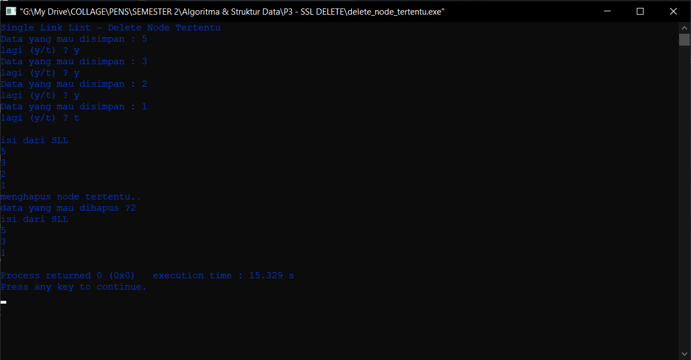

1. Menu Insert – Delete

Source Code :

|  |
| --- |
|  |